H.T No
Regulations:
A22

Sreenidhi Institute of Science and Technology
(An Autonomous Institution)
Code No: 9B513 Date: 16-January-2025(AN)

B.Tech III-Year I- Semester External Examination, January - 2024 (REGULAR)
COMPUTER AIDED MACHINE DRAWING (ME)

Time: 3 Hours Max.Marks:70

Note: a) No additional answer sheets will be provided.
b) All sub-parts of a question must be answered at one place only, otherwise it will not be valued.
c) Missing data can be assumed suitably.

Bloom's Cognitive Levels of Learning (BCLL)

Remember | L1 | Apply | L3 | Evaluate | L5
Understand | L2 | Analyze | L4 | Create | L6

Part - A Max.Marks:20

ANSWER ANY TWO QUESTIONS. EACH QUESTION CARRIES 10 MARKS.

1. | Draw the three Views of Hexagonal headed bolt of Nominal Diameter 30 mm and length 100 mm with a Hexagonal nut and Washer | L3 | [10M]
2. | Draw the Sectional Front view and Top view of the Cotter Joint with sleeve used to connect two rods of 50 mm each | L3 | [10M]
3. | Draw the sectional Front view and Top view of the following Riveted joint, to join plates of 12 mm double riveted, double strap butt joint | L4 | [10M]

Part-B (Compulsory) Max.Marks:40

4. |  | Assemble all the parts of the Plumber block, shown in Figure and draw the sectional front view and top view.  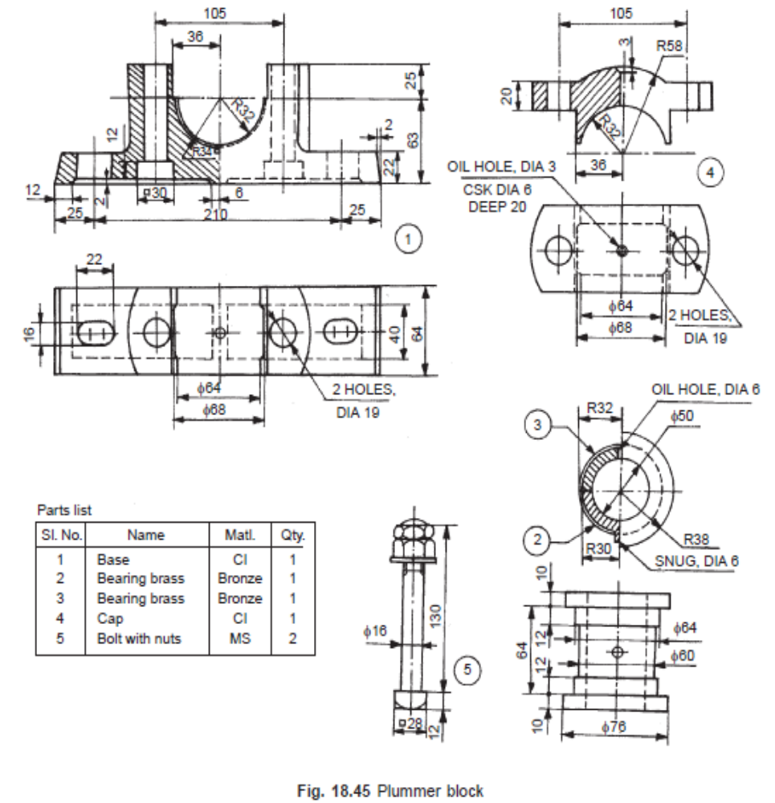 | L4 | 40M

-- 00 -- 00 –

